

**CROWDFUNDING**

A PROJECT REPORT

**RK UNIVERSITY, RAJKOT**

## SUBMITTED BY

### Name of Student Enrollment No.

Vadiya Om 21SOECE11100

Sorathiya Sunil 21SOEIT11032

## UNDER THE GUIDANCE OF

## INTERNAL GUIDE

## PROF. Nikunj Vadher

## ASST. Professor,

## RK University.

## RAJKOT



## SCHOOL OF ENGINEERING, RK UNIVERSITY, RAJKOT

# **TABLE OF CONTENTS**

|  |  |
| --- | --- |
| **TITLE** | **PAGE NO.** |
| **ACKNOWLEDGEMENT** | **05** |
| **ABSTRACT** | **06** |
| **1. INTRODUCTION** | **07** |
| **1.1 PROJECT SUMMARY** | **07** |
| **1.2 PURPOSE** | **08** |
| **1.3 MERN, MongoDB, Express ,React ,Nodejs** | **09** |
| **2. PROJECT MANAGEMENT** | **10** |
| **2.1 PROJECT PLANNING AND SCHEDULING** | **10** |
| **2.1.1 PROJECT DEVELOPMENT APPROACH** | **11** |
| **2.1.2 PROJECT PLAN** | **11** |
| **2.1.3 SCHEDULE REPRESENTATION** | **13** |
| **3. SYSTEM REQUIREMENTS STUDY** | **14** |
| **3.1 USER CHARACTERISTICS** | **14** |
| **3.2 HARDWARE** | **15** |
| **4. SYSTEM ANALYSIS** | **16** |
| **4.1 STUDY OF CURRENT SYSTEM** | **16** |
| **4.2 PROBLEM & WEAKNESS OF CURRENT SYSTEM** | **17** |
| **4.3 FEASIBILITY STUDY** | **17** |
| **4.4 REQUIREMENT VALIDATION** | **18** |
| **4.5 FUNCTION SYSTEM** | **19** |
| **4.5.1 USE CASE DIAGRAM** | **19** |
| **4.6 DATA MODELING** | **23** |

|  |  |
| --- | --- |
| **4.7 MAIN MODULES OF NEW SYSTEM** | **23** |
| **5. SYSTEM DESIGN** | **25** |
| **5.1 FLOW CHART** | **25** |
| **6. TESTING** | **27** |
| **6.1 TEST PLAN** | **27** |
| **6.2 TESTING STRATEGY** | **27** |
| **6.3 TESTING METHODS** | **28** |
| **6.4 TESTING CASES** | **29** |
| **7. SCREEN SHOTS** | **30** |
| **8. LIMITATION & FUTURE ENHANCEMENT** | **42** |
| **9. CONCLUSION AND DISCUSSION** | **43** |
| **10 REFERENCES** | **44** |

**ACKNOWLEDGEMENT**

The success and outcome of this project required a lot of guidance and assistance from many people, and We are extremely fortunate to have got this all along the completion of my project work. Whatever we have done is only due to such guidance and assistance and we should not forget to thank them.

We respect and thank RK University for giving us an opportunity to do the project work in 1MCA and providing us with all the support and guidance which will make us complete the project on time. We are extremely grateful to him for providing such nice support and guidance though he had a busy schedule managing the company affairs.

We also thank our internal project guide, Prof. Parvez Belim, RK University Rajkot, for his guidance and suggestions during this project work.

We are thankful to and fortunate enough to get constant encouragement, support, and guidance from all Teaching staff of the Department of Master of Computer Application which helped us in successfully completing our project work. Also, we would like to extend our sincere regards to all the non-teaching staff of the department for their timely support.

**ABSTRACT**

In an era marked by global challenges and the need for collective action, effective fundraising stands as a cornerstone for supporting impactful causes. This abstract introduces a comprehensive fundraising platform designed to empower organizations and individuals in their endeavors to drive positive change.

The primary goal of this fundraising platform is to provide a robust and user-friendly ecosystem that facilitates seamless interactions between fundraisers and donors. By leveraging innovative technologies and incorporating user-centric design principles, the platform aims to enhance the efficiency, transparency, and overall success of fundraising campaigns.

**1. INTRODUCTION**

In a world facing a myriad of challenges, the spirit of altruism and collective action has never been more vital. This introduction sets the stage for a dynamic fundraising initiative that goes beyond mere financial transactions, aiming to create a transformative impact on causes that resonate with the hearts and minds of individuals.

**1.1 PROJECT SUMMARY**

Objective:

The primary goal of this fundraising platform is to provide a robust and user-friendly ecosystem that facilitates seamless interactions between fundraisers and donors. By leveraging innovative technologies and incorporating user-centric design principles, the platform aims to enhance the efficiency, transparency, and overall success of fundraising campaigns.

Key Features:

* **Multi-Channel Fundraising:**
  + The platform supports diverse fundraising channels, including online donations, events, peer-to-peer fundraising, and merchandise sales, providing flexibility for campaign organizers to choose the most suitable approach.
* **Engagement and Communication Tools:**
  + Built-in communication tools foster meaningful engagement between campaign organizers and donors. Regular updates, personalized messages, and social media integration contribute to a vibrant and connected fundraising community.
* **Transparent Financial Management:**
  + Robust financial management features ensure transparency in fund utilization. Detailed reporting and real-time tracking enable donors to witness the direct impact of their contributions, building trust and accountability.
* **User-Friendly Interface:**
  + The platform prioritizes a user-friendly interface, catering to donors of all technological proficiencies. Intuitive navigation, clear calls-to-action, and responsive design contribute to a positive user experience.

**1.2 PURPOSE**

**Financial Support:**

* + The primary and most immediate purpose of fundraising is to generate financial resources. These funds are crucial for sustaining and advancing the mission of an organization or supporting a specific cause.
* **Mission Advancement:**
  + Fundraising enables organizations to advance their core mission and objectives. Whether it's supporting medical research, addressing social issues, or contributing to community development, funds raised play a direct role in achieving these goals.
* **Program Implementation:**
  + Organizations often design programs and initiatives to create a positive impact. Fundraising provides the necessary resources to implement and sustain these programs, ranging from educational initiatives to healthcare services.
* **Capacity Building:**
  + Financial support gained through fundraising allows organizations to build and enhance their capacity. This includes investing in human resources, infrastructure, technology, and other resources needed to operate effectively.
* **Research and Development:**
  + For institutions involved in research, particularly in fields like science, medicine, or technology, fundraising is essential for funding ongoing research projects and fostering innovation.
* **Community Engagement:**
  + Fundraising initiatives provide a platform for community engagement. They bring people together around a shared cause, fostering a sense of belonging and collective responsibility for positive change.
* **Emergency and Crisis Response:**
  + Fundraising can be mobilized swiftly in response to emergencies, disasters, or crises. Rapidly raised funds can provide immediate relief and support for affected communities.

**1.3 MERN, MongoDB, Express, React, Nodejs**

**MongoDB -> Database**

MongoDB is a popular NoSQL database that stores data in a flexible, JSON-like format known as BSON (Binary JSON). It's designed to be scalable and provide high performance for both read and write operations. MongoDB is often used in various types of applications, including web and mobile development.

**Express and NodeJS -> Backend**

Node.js and Express are commonly used together to build the backend of web applications.

**React -> Frontend**

React is a JavaScript library for building user interfaces, and it's widely used for developing the frontend of modern web applications.

**2. Project Management:**

* Discuss the structure of reward-based crowdfunding, where backers receive non-financial rewards.
* Explore equity crowdfunding, emphasizing the exchange of financial backing for a share in the project or company.
* Able to create a project on the system..
* Able to optionally provide rewards for funders.
* Able to update the project to show the progress of how they’ve developed.
* Provide a summary of the report's main points and their implications for future crowdfunding projects.

**2.1 PROJECT PLANNING AND SCHEDULING**

* Define Project Objectives and Scope
* Conduct Market Research
* Set Realistic Funding Goals
* Create a Detailed Budget
* Select the Right Crowdfunding Platform
* Build a Pre-launch Marketing Strategy
* Design and Prepare Campaign Assets
* Set a Campaign Timeline
* Identify Key Milestones

**2.1.1 PROJECT DEVELOPMENT APPROACH**

1. Idea Generation and Validation

Conceptualize: Generate a unique and compelling project idea.

Validate: Conduct market research to ensure there's demand for your project.

2. Define Clear Objectives and Scope

Set Goals: Clearly outline the project's goals, both in terms of funding and project outcomes.

Scope Definition: Clearly define what the project will deliver and its intended impact.

3. Create a Comprehensive Business Plan

Budgeting: Develop a detailed budget outlining all project costs.

Revenue Model: Clearly define how funds will be generated and utilized.

**2.1.2 PROJECT PLAN**

Our website is a crowdfunding platform based in India that facilitates fundraising for various causes, including medical emergencies, education, social causes, creative projects, and more. Please note that the information provided here might be subject to change, and it's a good idea to visit our official website or contact them directly for the most up-to-date details.

Here are some common features and services that Ketto provides for fundraising:

**Campaign Creation:**

* + Users can create fundraising campaigns for a variety of purposes, such as medical treatment, education, disaster relief, or personal projects.
* **Donation Collection:**
  + We allow individuals and organizations to collect donations online. Donors can contribute to campaigns easily through the platform.
* **Verification and Validation:**
  + We may implement verification processes to ensure the legitimacy of campaigns. This is especially important for medical fundraisers to avoid misuse.
* **Medical Fundraisers:**
  + The website is known for hosting a significant number of medical fundraisers. Users often turn to the platform to raise funds for medical treatments, surgeries, and other healthcare-related expenses.
* **Education Fundraisers:**
  + Fundraising campaigns for educational purposes, such as school fees, college tuition, or vocational training, can be created on the platform.
* **NGO and Social Causes:**
  + NGOs and individuals working on social causes can use Ketto to raise funds for their projects.
* **Creative and Personal Projects:**
  + We support campaigns for creative projects, innovations, and personal initiatives that align with the platform's guidelines.
* **Transparent Fund Utilization:**
  + Campaign creators often provide updates on fund utilization, helping donors understand how their contributions are making an impact.
* **Support and Outreach:**
  + We may provide support and guidance to campaign creators on optimizing their fundraising efforts, including tips on creating compelling campaigns and reaching a wider audience.
* **Payment Gateway Integration:**
  + We integrate with payment gateways to facilitate secure transactions. Donors can contribute using various payment methods.
* **Social Sharing:**
  + Users can share their campaigns on social media platforms to increase visibility and reach a larger audience.
* **Reviews and Testimonials:**
  + We may feature reviews and testimonials from individuals who have successfully raised funds on the platform.

**2.1.3 SCHEDULE REPRESENTATION**

Schedule representation for fundraising involves planning and organizing key activities to ensure a successful campaign. Below is a sample schedule representation for a crowdfunding campaign. Keep in mind that the duration and specific activities may vary based on the nature of the fundraiser, the goals, and the platform used.

**1: Pre-Launch Preparation**

* Define Campaign Goals and Strategy
* Create Compelling Campaign Content
* Set Up Campaign Page

### **2: Launch and Initial Outreach**

* Launch the Campaign
* Initial Outreach
* Media Outreach

### **3: Mid-Campaign Boost**

* Analyze Early Results
* Expand Outreach
* Collaborations and Partnerships

### **4: Final Push and Post-Campaign Planning**

* Final Push
* Post-Campaign Preparation

**3. SYSTEM REQUIREMENTS STUDY**

**Software Requirements:**

Building a fundraising platform involves several software components to ensure a smooth and secure experience for both campaign creators and donors. Below are key software requirements for a fundraising platform:

* **Web Application Framework:**
  + Choose a robust web application framework to develop the front-end and back-end of the fundraising platform. Popular choices include:
  + React for the frontend.
  + express and NodeJS for the backend.
* **Database Management System:**
  + Select a reliable database management system (DBMS) to store and manage campaign data. Common options include:
  + MongoDB => Database
* **Server Hosting:**
  + Choose a scalable and reliable server hosting platform to deploy your application. Options include:
  + Amazon Web Services (AWS), Microsoft Azure, Google Cloud Platform, or Heroku.
* **Payment Gateway Integration:**
  + Integrate a secure and widely used payment gateway to handle financial transactions. Examples include:
  + Stripe, PayPal, Razor pays, or other region-specific payment gateways.

**3.1 USER CHARACTERISTICS**

The characteristics of your target users are crucial for developing effective fundraising strategies. Here are key user characteristics to consider:

* **Demographics:**
  + Age: Different age groups may respond differently to fundraising appeals. Tailor your message and platform to appeal to the age range of your target audience.
  + Gender: Consider gender-specific preferences and interests that may influence donation behaviors.
* **Geographical Location:**
  + Location: Know where your audience is located, as this can impact their accessibility to certain causes or events.
* **Income Level:**
  + Understand the income levels of your target users. This information helps determine appropriate donation amounts and strategies.
* **Occupation:**
  + Consider the occupations of your potential donors. Professionals in certain industries may be more inclined to support specific causes.

**3.2 HARDWARE**

There are some hardware considerations and tools that may be relevant to the overall fundraising process, especially in terms of campaign promotion, events, and communication. Here are some hardware-related considerations for fundraising:

**Computers and Laptops:**

* For campaign organizers and teams managing the fundraising efforts, having access to reliable computers or laptops is essential for communication, data management, and planning.
* **Smartphones and Tablets:**
  + Mobile devices are crucial for engaging with donors and supporters through social media, emails, and messaging apps. They also enable organizers to stay connected and manage campaigns on the go.
* **Cameras and Video Equipment:**
  + High-quality visuals can significantly impact the success of a fundraising campaign. Cameras or smartphones with good cameras, as well as video equipment for creating compelling content, may be useful.
* **Audio Equipment:**
  + For virtual events, webinars, or video content, having quality audio equipment such as microphones can enhance the user experience and convey your message more effectively.

**4. SYSTEM ANALYSIS**

**4.1 STUDY OF CURRENT SYSTEM**

Conducting a study of the current system for fundraising involves evaluating existing processes, tools, and strategies to identify strengths, weaknesses, and areas for improvement.

### **1. Define Objectives:**

* Clearly define the objectives of your study. Understand what specific aspects of the current fundraising system you want to assess, such as donor engagement, campaign effectiveness, or operational efficiency.

### **2. Identify Stakeholders:**

* Determine the key stakeholders involved in the fundraising process, including campaign organizers, donors, and supporting staff. Understand their roles and perspectives.

### **3. Review Documentation:**

* Gather and review existing documentation related to fundraising processes, strategies, and outcomes. This may include campaign reports, financial records, and communication plans.

### **4. Interview Key Personnel:**

* Conduct interviews with key personnel involved in fundraising, including campaign managers, organizers, and support staff. Collect insights on their experiences, challenges, and suggestions for improvement.

### **5. Survey Donors and Supporters:**

* Create surveys or conduct interviews with donors and supporters. Understand their motivations for contributing, their satisfaction with the current system, and any suggestions they may have.

**4.2 PROBLEM & WEAKNESS OF CURRENT SYSTEM**

Identifying the problems and weaknesses in the current fundraising system is a crucial step in improving and optimizing the overall process. Here are common issues that organizations might face in their fundraising efforts:

### **1. Lack of Digital Presence:**

* Problem: Insufficient online visibility and engagement.
* Impact: Limits the reach of fundraising campaigns to a wider audience.
* Potential Weakness: Outdated or static websites, minimal use of social media.

### **2. Ineffective Communication:**

* Problem: Poor communication with donors and supporters.
* Impact: Decreased donor engagement and lack of awareness about ongoing campaigns.
* Potential Weakness: Infrequent updates, unclear messaging, or ineffective use of communication channels.

### **3. Limited Technological Integration:**

* Problem: Outdated or inadequate fundraising platforms.
* Impact: Hinders the ease of donation, reduces donor trust, and limits campaign features.
* Potential Weakness: Lack of integration with modern payment gateways, poor user experience on the fundraising website.

### **4. Insufficient Data Management:**

* Problem: Poor handling and utilization of donor data.
* Impact: Missed opportunities for personalized engagement and targeted fundraising.
* Potential Weakness: Incomplete or inaccurate donor information, lack of data analytics.

**4.3 FEASIBILITY STUDY**

A feasibility study for fundraising involves assessing the viability and practicality of a proposed fundraising project or campaign. This study helps organizations make informed decisions about whether to proceed with the fundraising initiative. Here are key elements to include in a feasibility study for fundraising:

### **1. Executive Summary:**

* Provide a brief overview of the fundraising initiative, including its purpose, goals, and potential impact.

### **2. Project Description:**

* Clearly define the fundraising project, outlining its objectives, target audience, and the cause or purpose it aims to support.

**4.4 REQUIREMENT VALIDATION**

Requirement validation is a crucial step in the development of a fundraising platform. It ensures that the identified requirements align with the goals of the fundraising initiative and meet the needs of both the organization and its stakeholders. Here's a step-by-step guide for requirement validation in the context of fundraising:

### **1. Define Stakeholders:**

* Identify and involve key stakeholders, including campaign organizers, donors, volunteers, and any other parties involved in or impacted by the fundraising platform.

### **2. Review Business Objectives:**

* Revisit and validate the business objectives of the fundraising initiative. Ensure that the requirements align with the overall goals and mission of the organization.

**4.5 FUNCTION SYSTEM**

**4.5.1 USE CASE DIAGRAM**

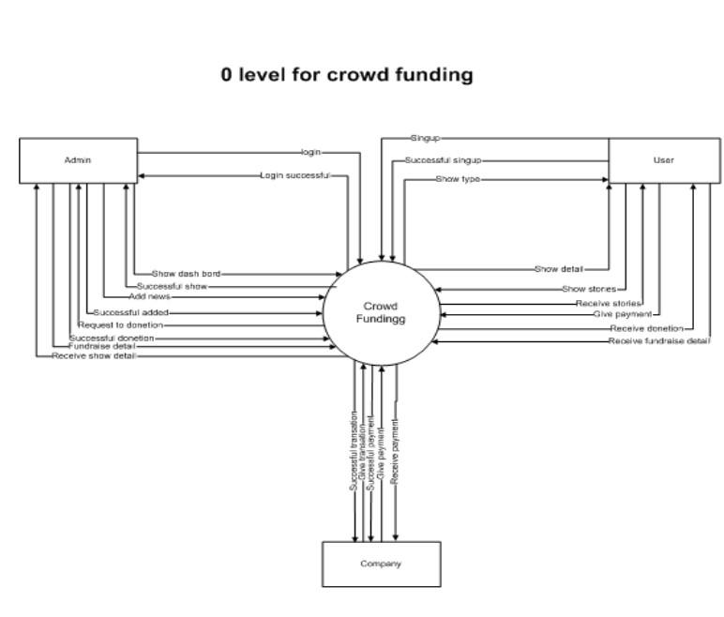

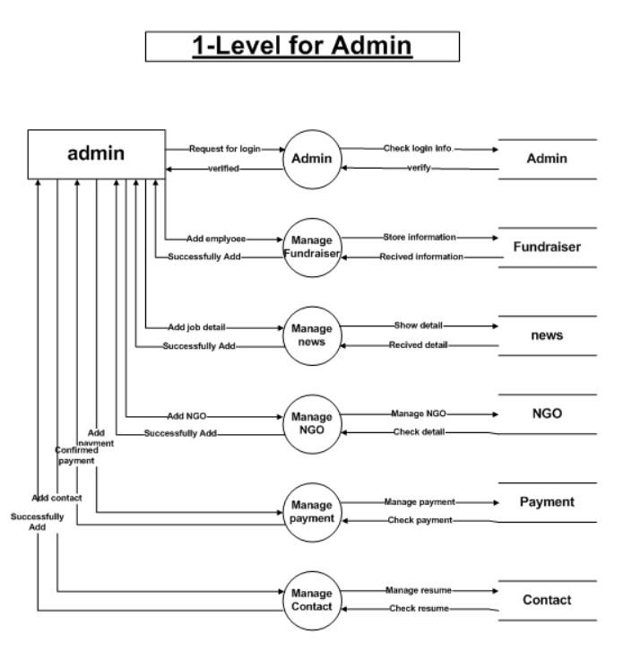

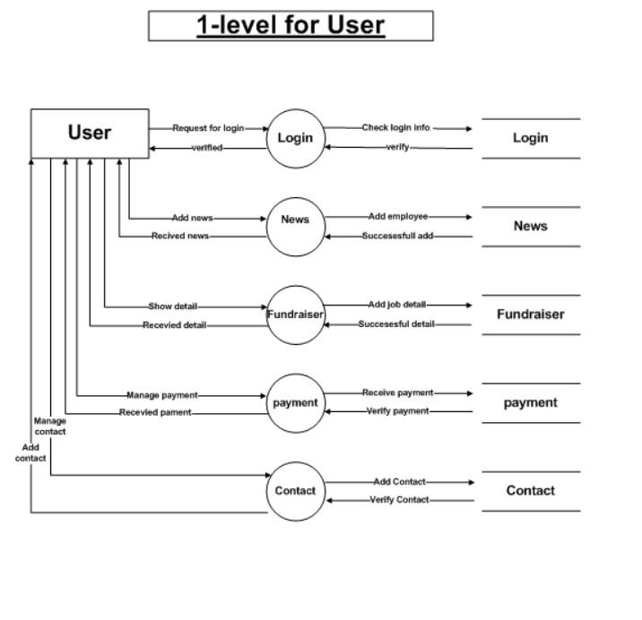

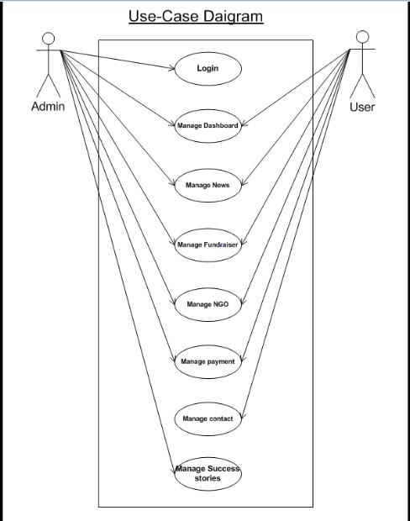

**ER Diagram**

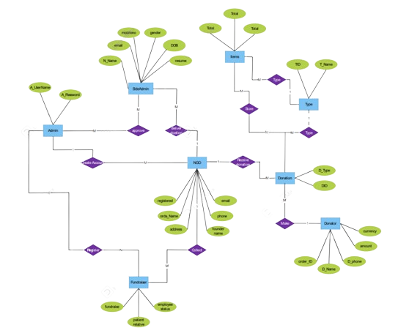

**4.6 DATA MODELING**

* Entities and Attributes:

Define entities like Campaign, User/Backer, and Transaction with key attributes such as CampaignID, UserID, Title, Amount, etc.

* Relationships:

Establish relationships, including many-to-many between Campaigns and Users (backers), and one-to-many between Campaigns and Transactions as well as Users and Transactions.

* Database Tables:

Create tables for Campaigns, Users, and Transactions with appropriate fields, data types, and foreign key relationships.

* Indexing:

Implement indexes on frequently queried columns like CampaignID and BackerID to enhance query performance.

* Considerations:

Ensure normalization for data integrity, scalability for future growth, and implement security measures to protect user and financial data.

* Additional Considerations:

Optimize queries for common use cases, implement logging for changes, and establish backup and recovery procedures to prevent data loss. Adjust the model based on specific platform features like rewards, comments, and updates.

**4.7 MAIN MODULES OF NEW SYSTEM**

Designing the main modules of a new fundraising system involves breaking down the system's functionality into distinct components or modules. Here are the main modules that could be considered for a comprehensive fundraising system:

### 1. Campaign Management Module

### 2. Donor Management Module

### 3. Transaction Processing Module

### 4. Reporting and Analytics Module

### 5. Communication and Engagement Module

### 6. Admin and User Management Module

### 7. Fund Allocation and Financial Management Module

### 8. Marketing and Promotion Module

### 9. Mobile Responsiveness Module

### 10. Integration and API Module

**5. SYSTEM DESIGN**

**5.1 FLOW CHART**

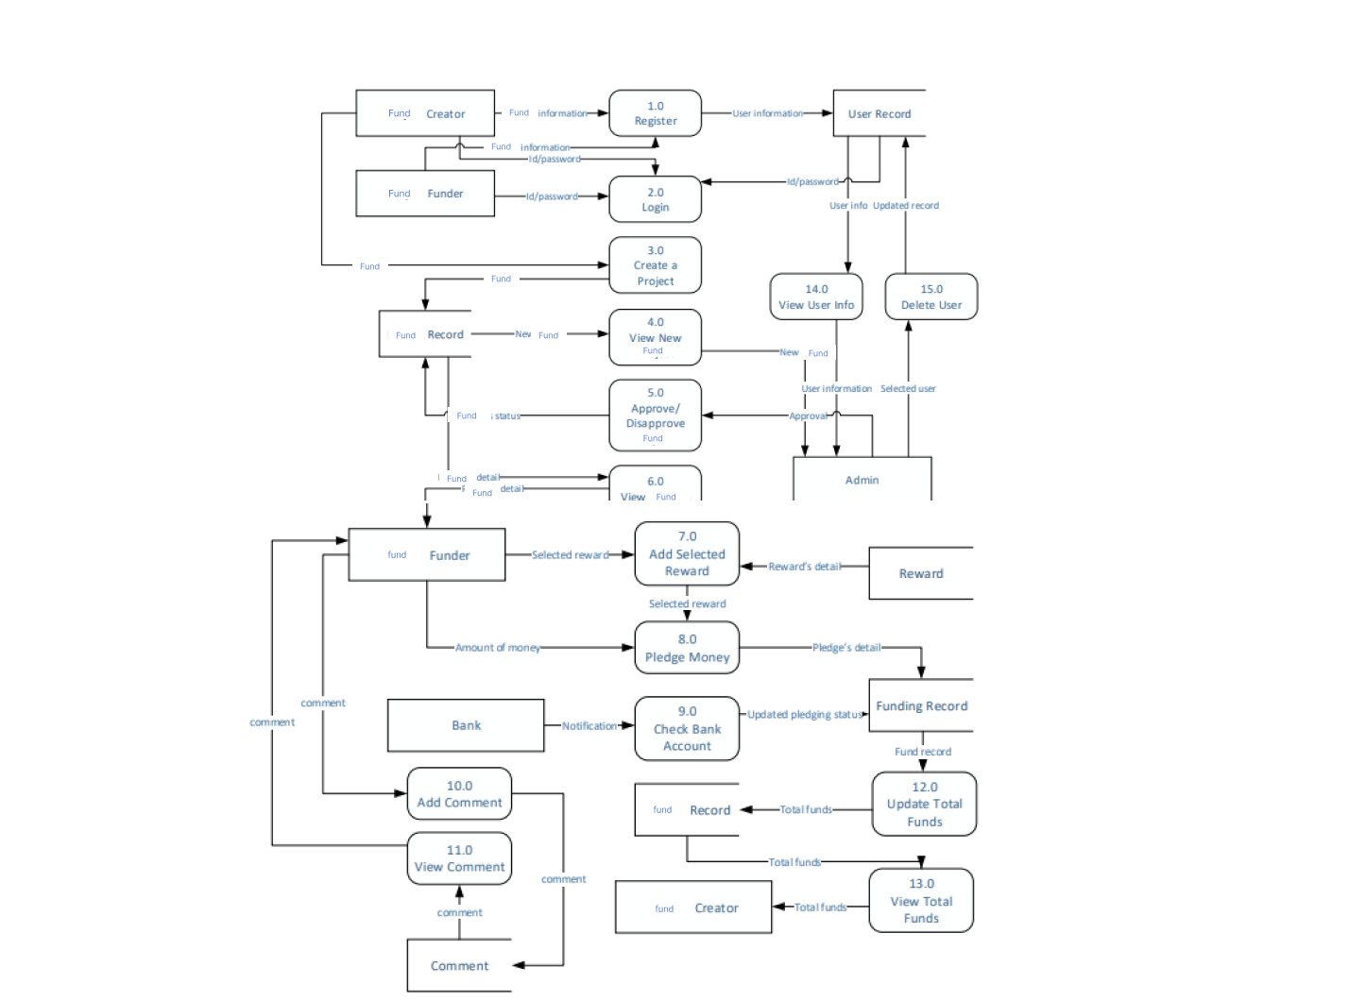

### 

### **Explanation of Flowchart Stages:**

* **Start:**
  + The starting point of the fundraising process.
* **Campaign Creation and Setup:**
  + Campaign organizers create and set up a fundraising campaign, defining goals, timelines, and other details.
* **Donor Outreach:**
  + Outreach activities to attract and engage potential donors.
* **Transaction Processing:**
  + online transactions, including secure donation processing,generating receipts.
* **Acknowledgment and Recognition:**
  + Thanking donors and recognizing their contributions.
* **Financial Management:**
  + Managing and allocating funds to specific campaigns.
* **Donor Engagement:**
  + Continued engagement with donors, providing fostering a sense of community.
* **Impact Reporting:**
  + Reporting on the impact of funds raised, demonstrating transparency.
* **Follow-up Communication:**
  + Continued communication with donors, updates on ongoing campaigns, and potential future engagement.
* **Reporting and Analytics:**
  + Analyzing campaign performance and donor behavior through reporting and analytics tools.
* **Continuous Improvement:**
  + Incorporating feedback and making continuous improvements to the fundraising process.
* **End:**
  + Endpoint of the fundraising process.

**6. TESTING**

**6.1 TEST PLAN**

A test plan for fundraising outlines the strategies, resources, and schedule for testing the fundraising system to ensure its functionality, security, and performance. Below is a sample test plan for a fundraising platform:

### 1. Objective:

* Ensure the fundraising platform meets functional, security, and performance requirements before deployment.

### 2. Scope:

* This test plan covers functional testing, security testing, and performance testing for the fundraising platform.

### 3. Testing Team:

### Identify testing team members and their roles:

* + Test Manager
  + Functional Testers
  + Security Testers
  + Performance Testers

**6.2 TESTING STRATEGY**

A testing strategy for fundraising involves defining the overall approach, methods, and resources for ensuring the quality and reliability of the fundraising platform. Here's a comprehensive testing strategy for a fundraising system:

### 1. Objective:

* Ensure the fundraising platform meets functional, security, and performance requirements, providing a seamless and secure experience for users.

### 2. Testing Types:

* Identify and plan for various testing types:
  + Functional Testing:
    - Unit Testing
    - Integration Testing
    - System Testing
  + Security Testing:
    - Vulnerability Assessment
    - Penetration Testing
  + Performance Testing:
    - Load Testing
    - Stress Testing
    - Scalability Testing
    - Speed and Responsiveness Testing
    - Cross-Browser Testing
    - Device Compatibility Testing

**6.3 TESTING METHODS**

Testing is crucial in the fundraising process to ensure that campaigns, platforms, and strategies are effective, user-friendly, and secure. Here are some testing methods for fundraising:

* **Usability Testing:**
  + Objective: Evaluate how user-friendly your donation platform is.
  + Method: Recruit participants to perform common tasks such as donating, sharing a campaign, or accessing donation history. Observe and gather feedback on their experience.
* **A/B Testing:**
  + Objective: Test different variations of elements (e.g., campaign headlines, images, call-to-action buttons) to identify the most effective combinations.
  + Method: Create two or more versions of a campaign and expose different segments of your audience to each version. Analyze which performs better in terms of donations and engagement.
* **Load Testing:**
  + Objective: Assess the capacity of your fundraising platform to handle a large number of simultaneous users.
  + Method: Simulate high traffic scenarios using tools to determine the point at which the platform experiences performance issues.
* **Security Testing:**
  + Objective: Identify and address potential vulnerabilities in your donation platform to ensure the safety of donor information.
  + Method: Conduct penetration testing and code reviews to find and fix security flaws.

**6.4 TESTING CASES**

Certainly! When testing cases for fundraising, it's important to consider various scenarios and elements that can impact the success of your fundraising efforts. Here are some testing cases you might want to consider:

* **Donation Platform Testing:**
  + Test the functionality of your donation platform to ensure a seamless and user-friendly experience for donors.
  + Verify that the payment gateway is working correctly and securely.
* **Mobile Responsiveness:**
  + Test your fundraising campaign page on different devices (desktops, tablets, smartphones) to ensure its responsive and accessible across various screen sizes.
* **Browser Compatibility:**
  + Check that your fundraising platform is compatible with popular web browsers such as Chrome, Firefox, Safari, and Edge.
* **Social Media Integration:**
  + Test the integration of social media sharing buttons to confirm that donors can easily share the campaign on platforms like Facebook, Twitter, and Instagram.
* **Email Campaign Testing:**
  + Ensure that automated emails for donation confirmation, thank-you notes, and updates are being sent correctly.
  + Test the email content to make sure it is clear, compelling, and error-free.
* **Security Testing:**
  + Conduct security testing to identify and address potential vulnerabilities in your donation platform, ensuring donor information is kept confidential.
* **Load Testing:**
  + Simulate high traffic scenarios to ensure your fundraising platform can handle many concurrent users without crashing or slowing down.
* **Data Validation:**
  + Validate user inputs to prevent errors in data submission and ensure accurate donor information.
* **Communication Channels:**
  + Test communication channels such as live chat, support emails, and helplines to ensure they are responsive and can handle inquiries effectively.
* **Performance Testing:**
  + Evaluate the overall performance of your fundraising platform, including page loading times and response times for various actions.
* **Accessibility Testing:**
  + Ensure your fundraising platform complies with accessibility standards, making it usable for individuals with disabilities.
* **Offline Donation Testing:**
  + If applicable, test the process for handling offline donations, such as checks or cash, to ensure they are accurately recorded and acknowledged.
* **Refund Process Testing:**
  + Verify that the refund process is in place and functioning correctly in case a donor requests a refund.

1. **SCREEN SHOTS**

**Admin side**

**1. Login**

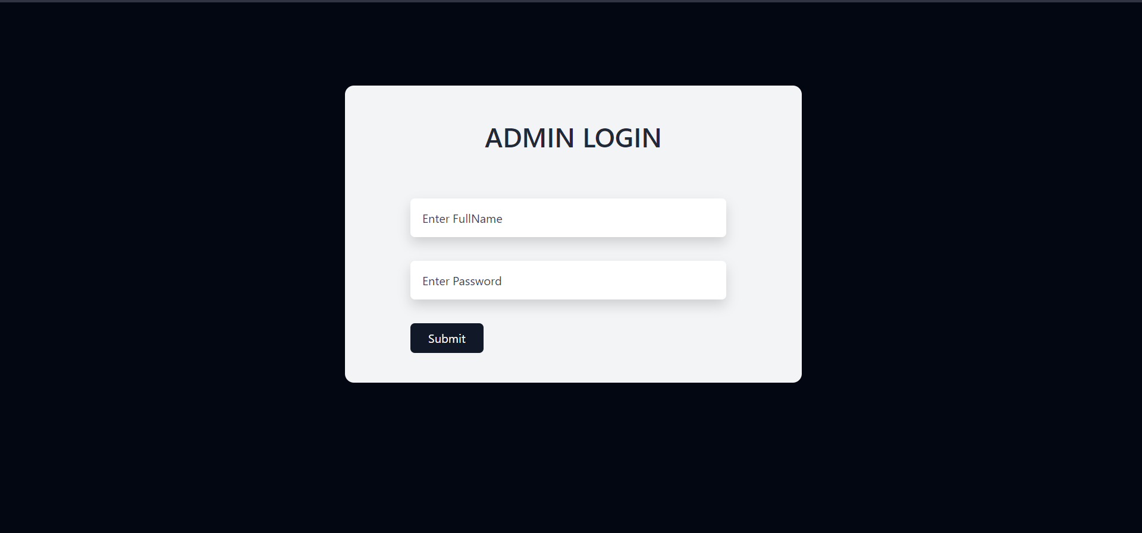

**2.Home**

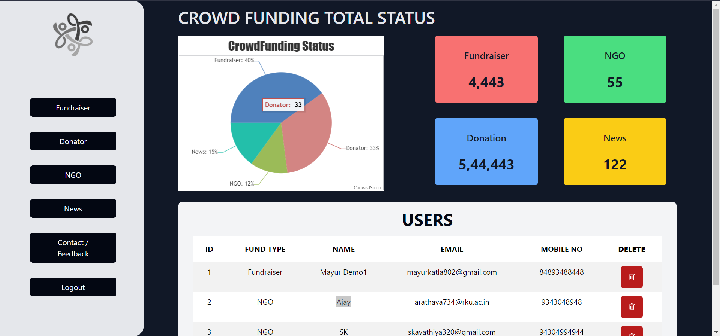

**3.News Details**

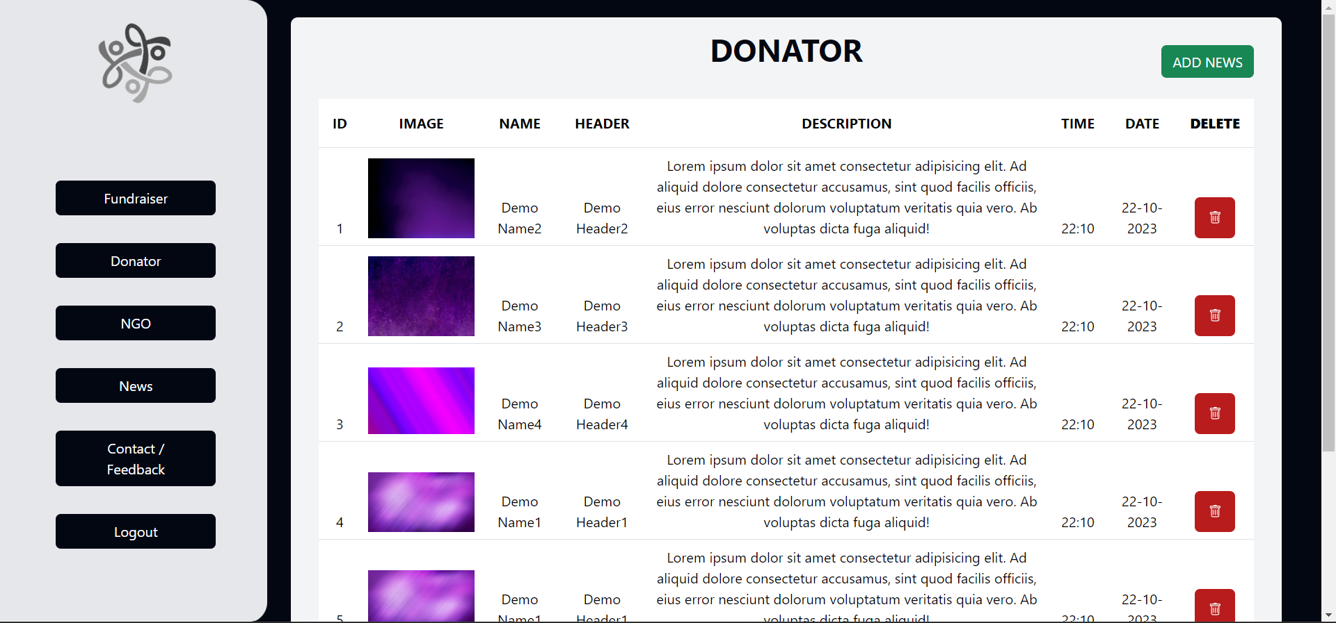

1. **Add News**

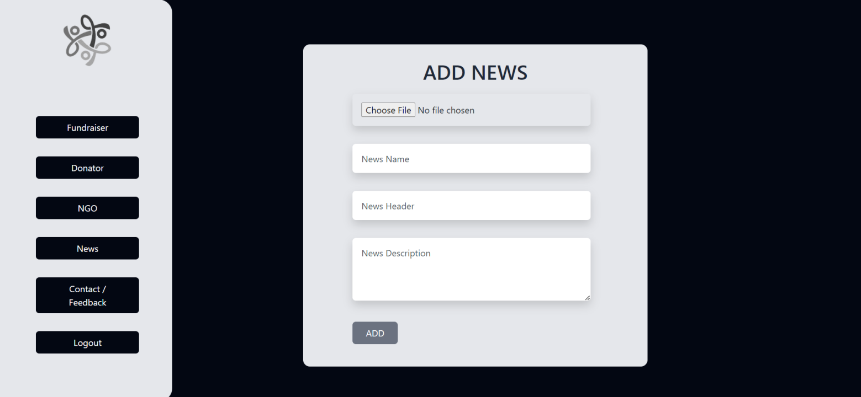

**5.Fundraiser Details**

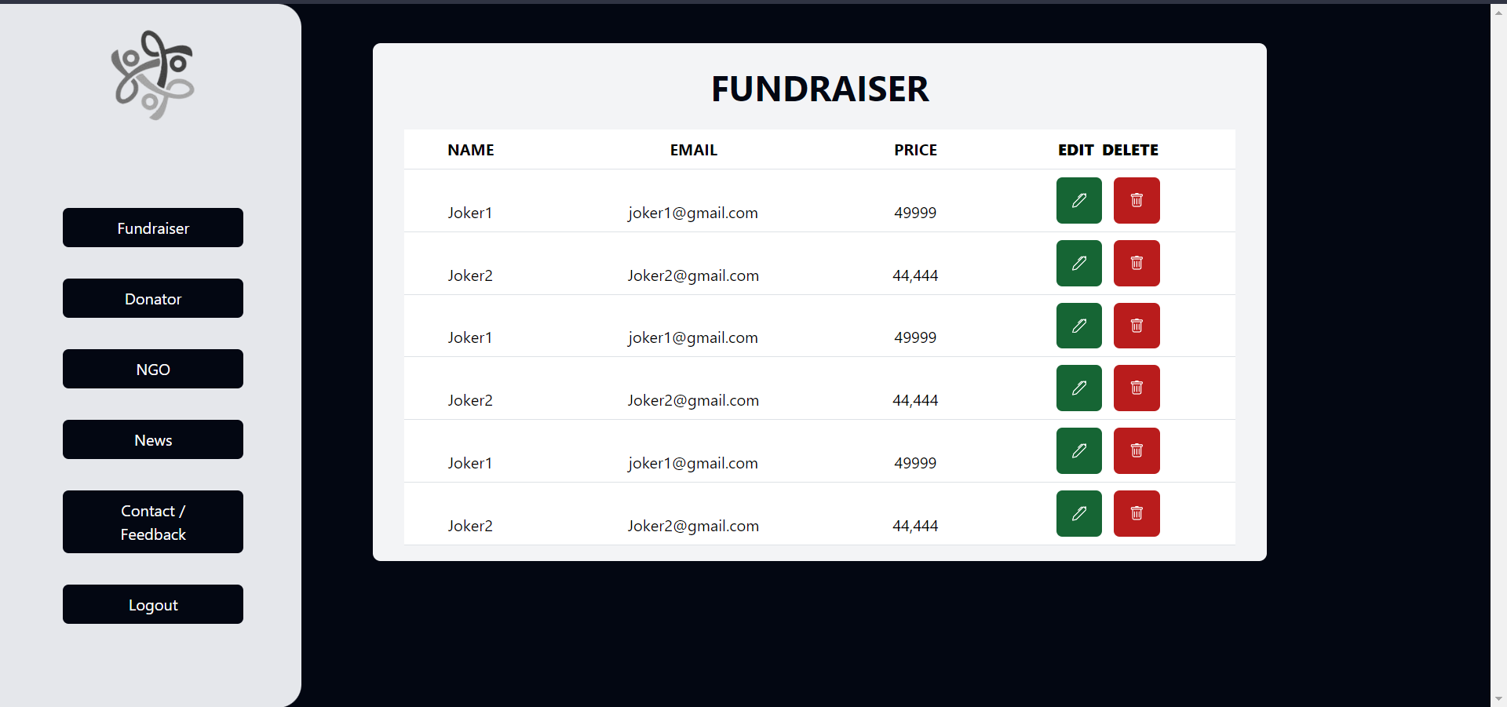

1. **Donator Details**

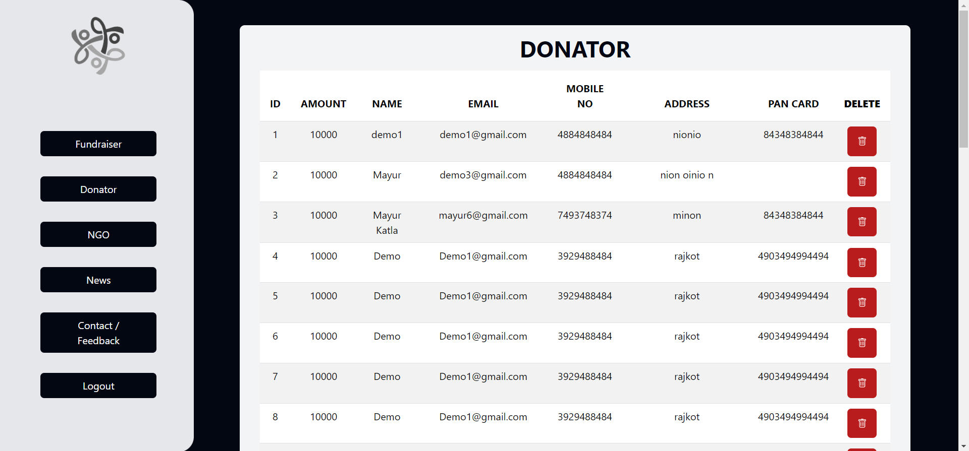

**6.Contact Details**

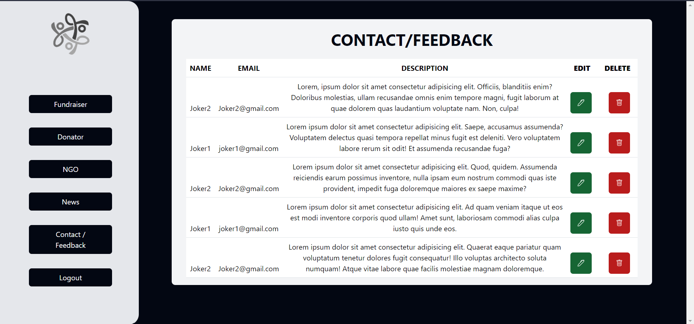

**7.NGO**

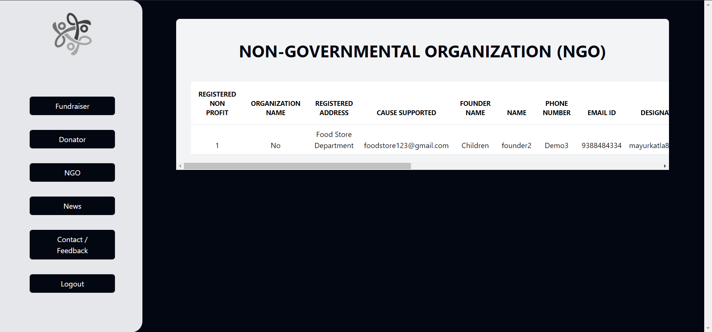

**USERS side**

1. **SIGNUP**

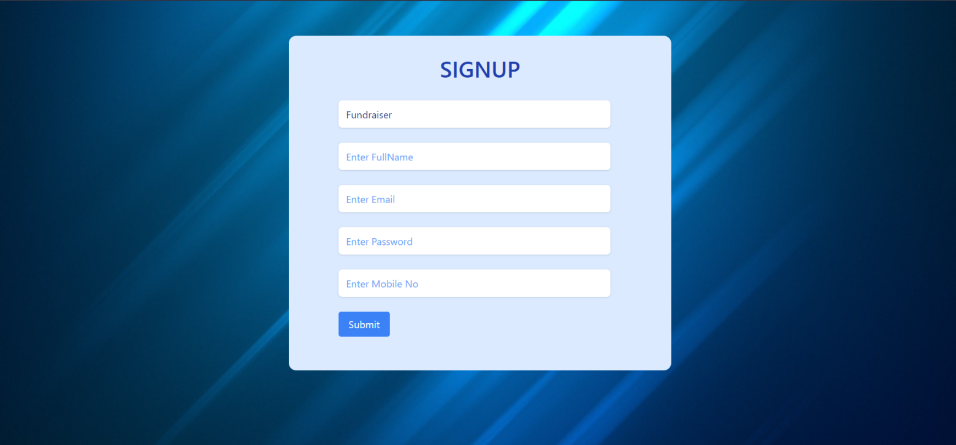

1. **LOGIN**

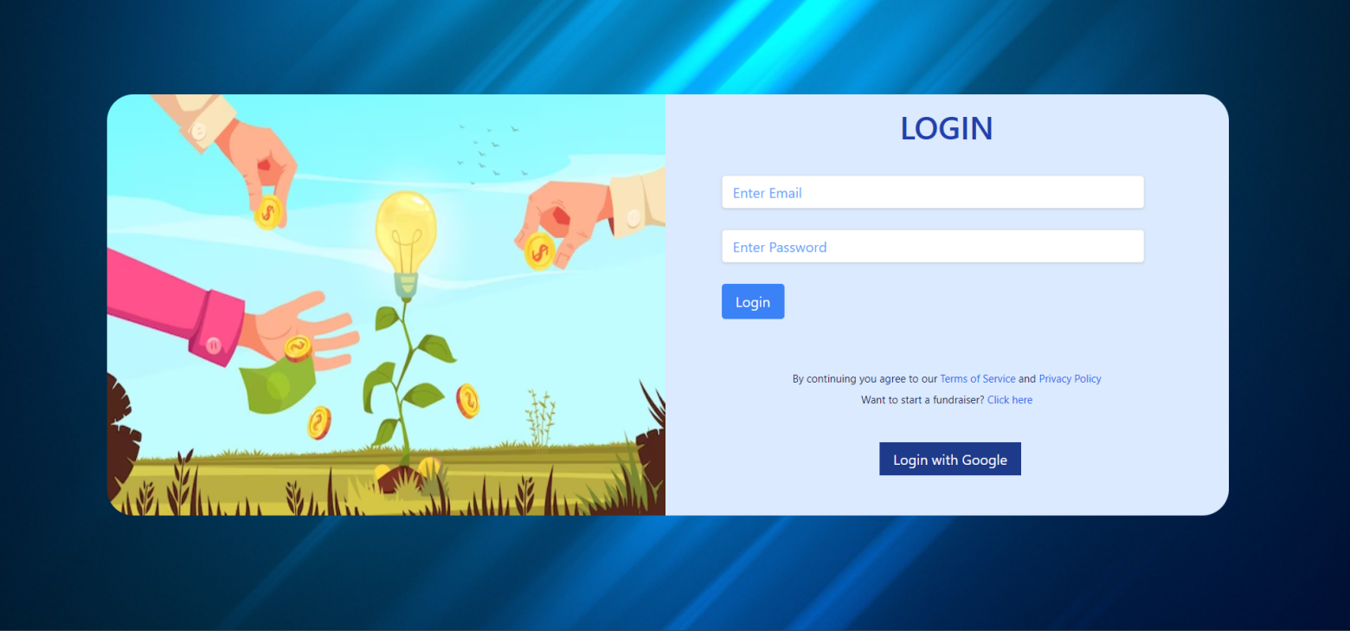

1. **HOME1**

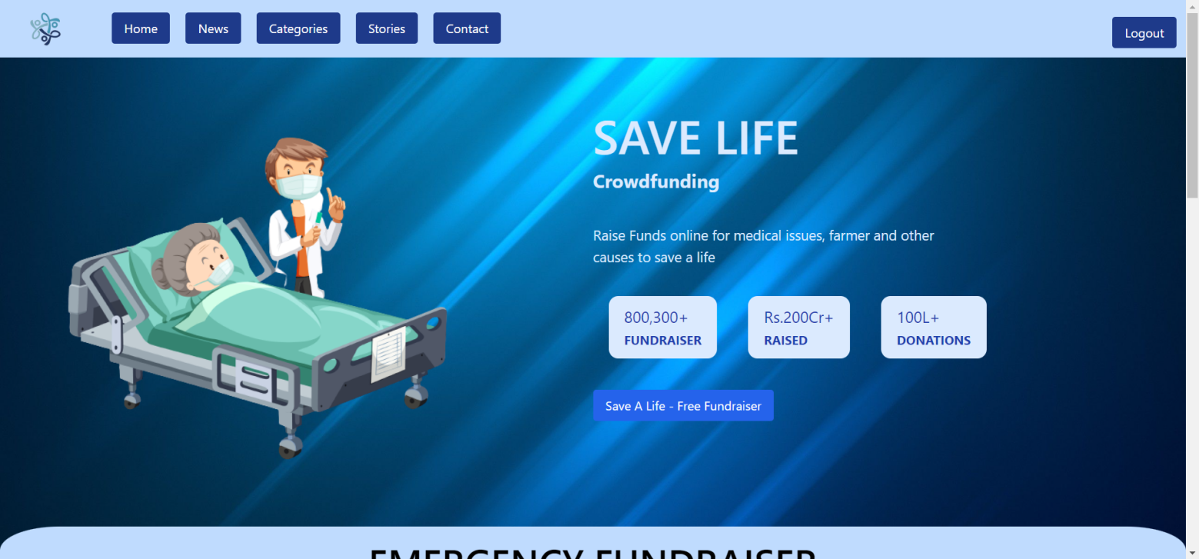

1. **HOME2**

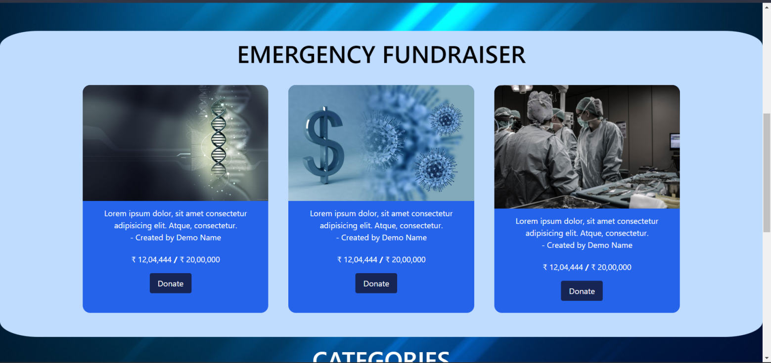

1. **HOME3**

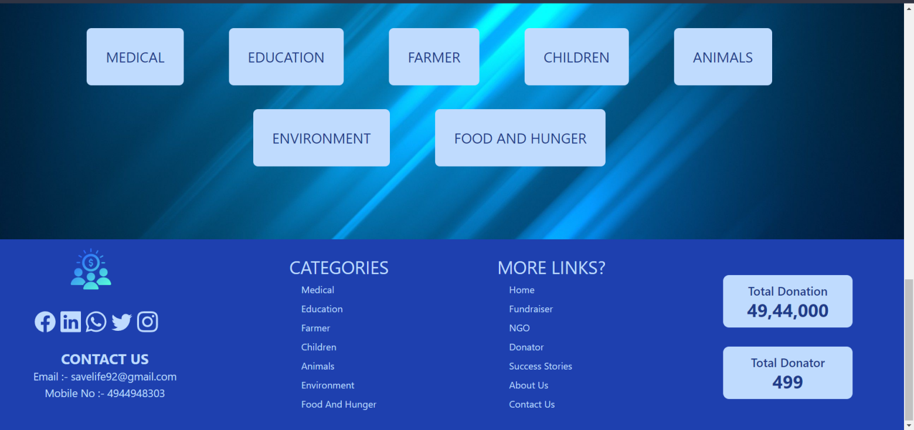

1. **NEWS**

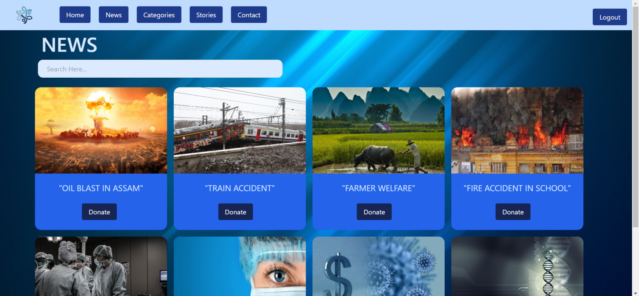

1. **CATEGORIES**

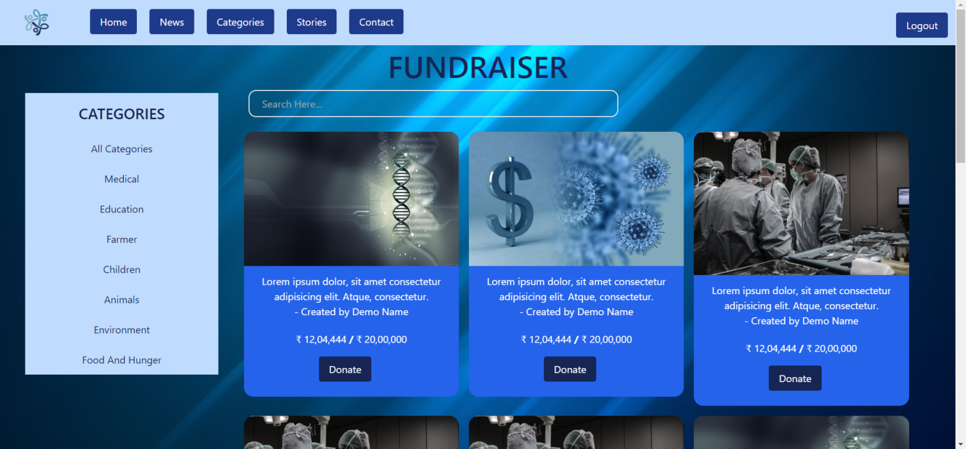

1. **ADD Fundraiser**

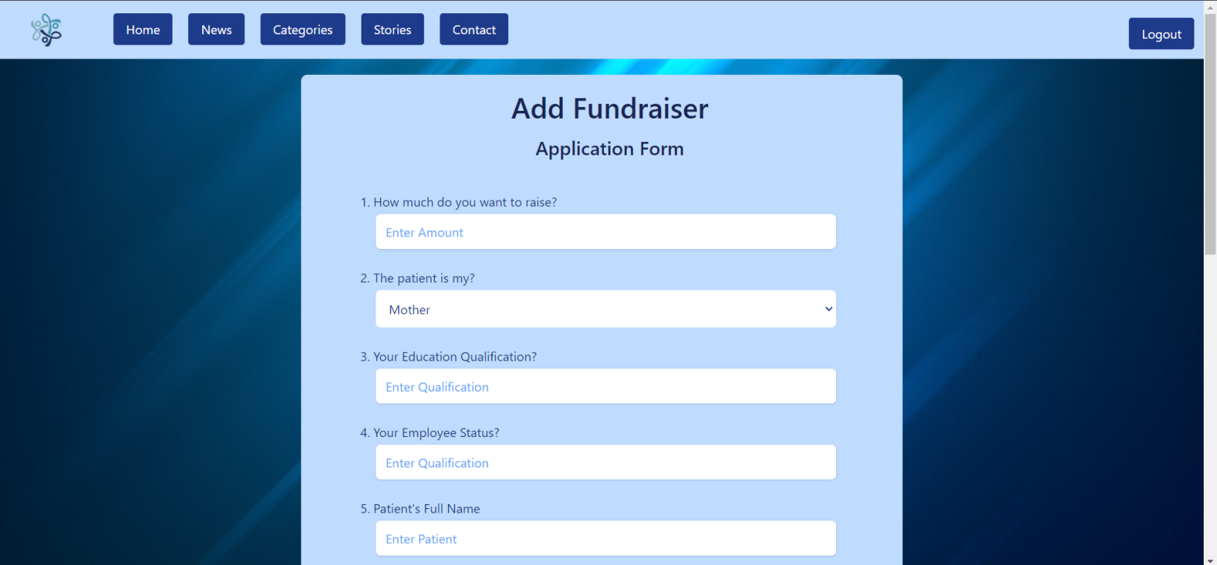

1. **CONTACT US**

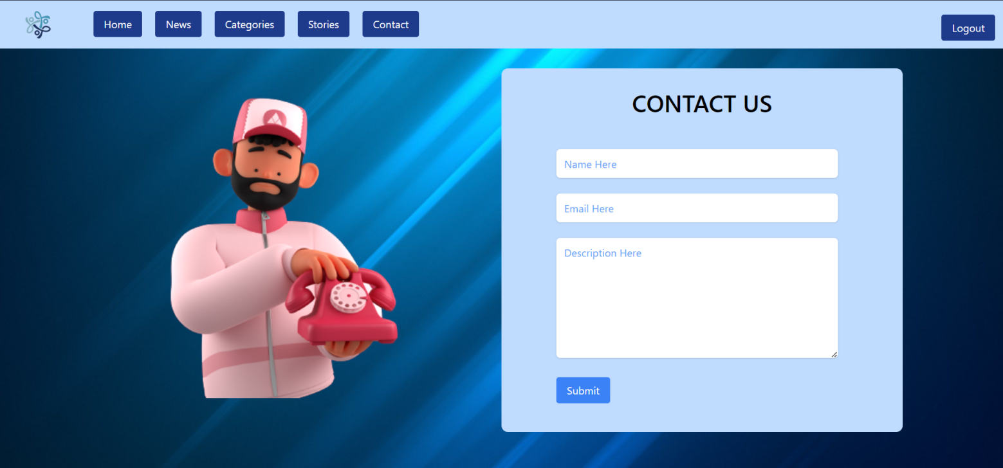

1. **PAYMENT**

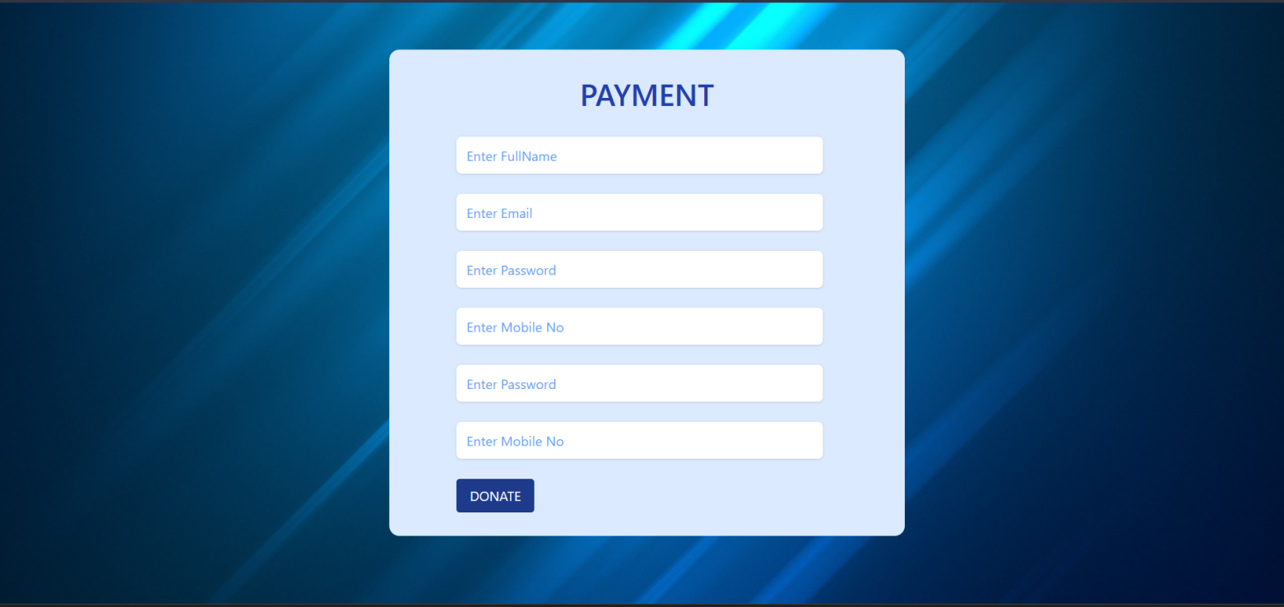

1. **PAYMENT2**

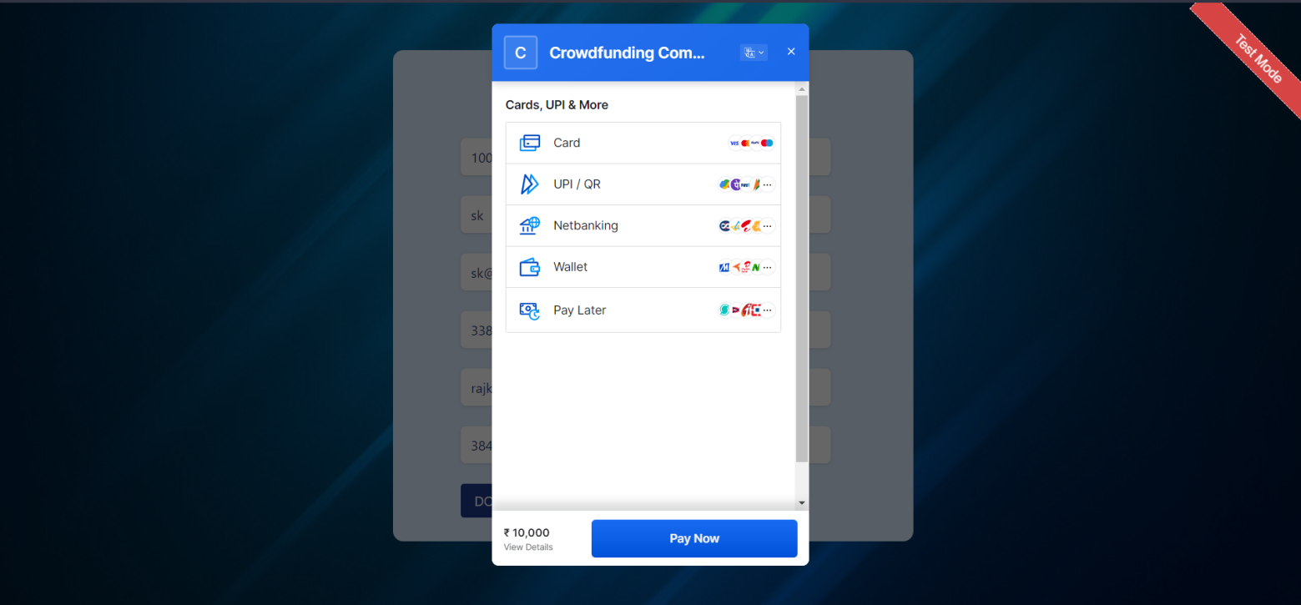

**12.PAYMENT3**

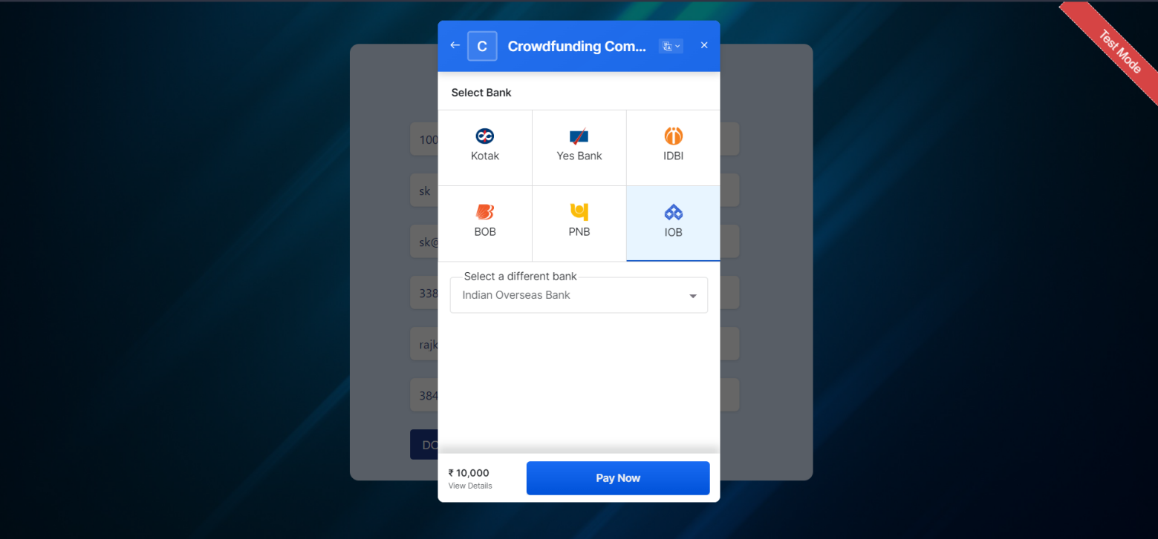

**13.PAYMENT4**

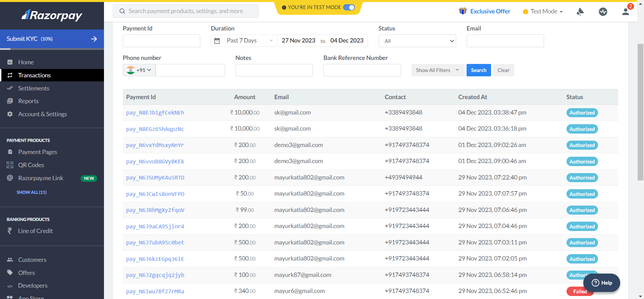

**14.PAYMENT5**

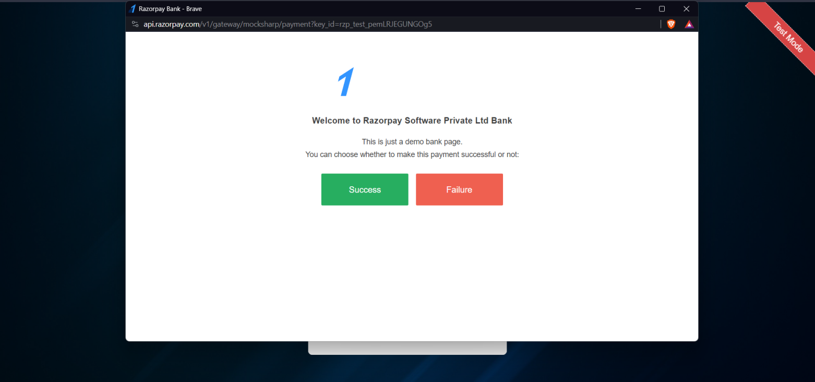

**15.PAYMENT6**

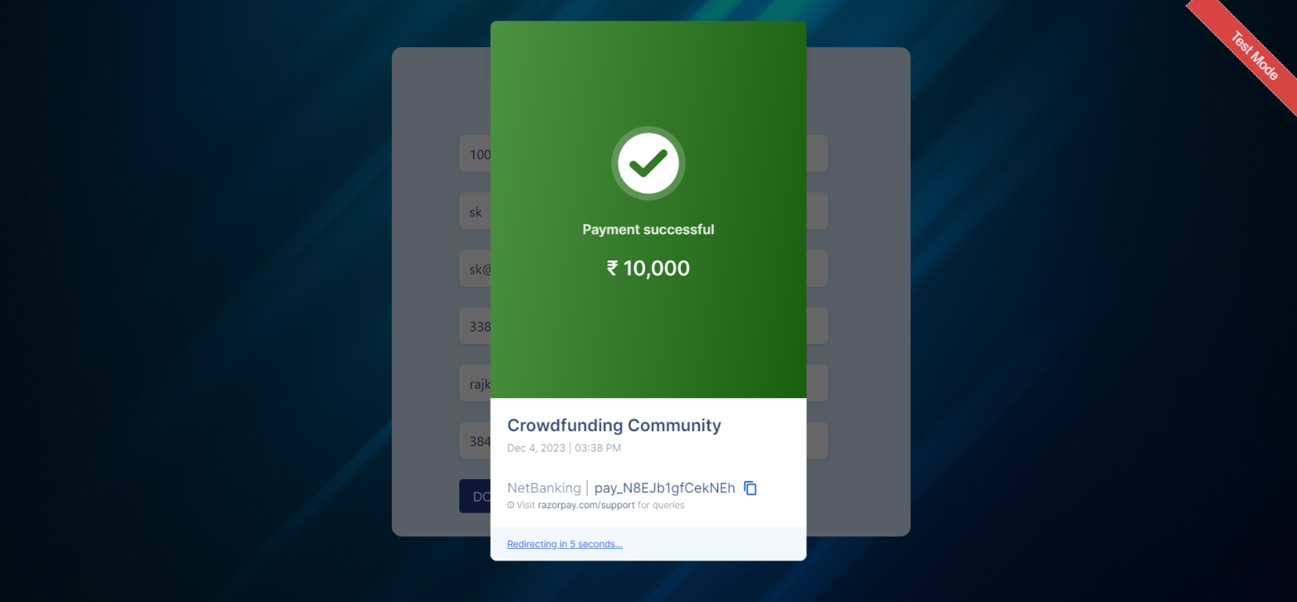

**8. LIMITATION & FUTURE ENHANCEMENT**

**Limitations:**

* **Limited Reach:**
  + Fundraising efforts may face limitations in reaching a broader audience, especially if the campaign relies on a specific platform or network.
* **Donor Fatigue:**
  + Donors may experience fatigue if they are repeatedly approached for contributions, potentially leading to reduced engagement and support.
* **Dependency on Economic Conditions:**
  + Economic downturns or unfavorable economic conditions can impact donors' ability to contribute, affecting fundraising goals.
* **Technology Barriers:**
  + Some potential donors may face barriers related to technology literacy or access, hindering their ability to contribute online.
* **Legal and Regulatory Challenges:**
  + Fundraising campaigns need to navigate complex legal and regulatory landscapes, and any oversight or non-compliance can lead to issues.
* **Competing Campaigns:**
  + The presence of numerous simultaneous fundraising campaigns, especially for similar causes, can dilute attention and support.
* **Trust Issues:**
  + Building and maintaining trust is crucial, and any incidents of misuse or mishandling of funds can significantly impact future fundraising efforts.

**Future Enhancements:**

* **Blockchain for Transparency:**
  + Implement blockchain technology to enhance transparency in financial transactions, providing donors with a secure and traceable way to track their contributions.
* **Personalized Campaigns:**
  + Utilize data analytics and machine learning to create personalized fundraising campaigns, tailoring messages and appeals to specific donor preferences and interests.
* **Virtual Reality (VR) Experiences:**
  + Integrate virtual reality experiences to immerse donors in the impact of their contributions, creating a more emotional connection and fostering long-term engagement.
* **AI-driven Donor Targeting:**
  + Use artificial intelligence to identify potential donors based on their online behavior, enabling more targeted outreach, and increasing the likelihood of successful campaigns.
* **Enhanced Mobile Fundraising Apps:**
  + Develop and improve mobile applications specifically designed for fundraising, providing a convenient and user-friendly platform for donors to contribute.
* **Social Media Integration:**
  + Further enhance integration with social media platforms, leveraging the power of social networks to increase campaign visibility and encourage peer-to-peer fundraising.

**9. CONCLUSION AND DISCUSSION**

**Conclusion:**

In conclusion, fundraising plays a pivotal role in supporting various causes and initiatives, providing the financial resources necessary for organizations to make a positive impact on the world. Throughout the process of fundraising, it is essential to recognize both the achievements and challenges faced. The collective efforts of donors, campaigners, and the broader community contribute to the success of fundraising campaigns, enabling organizations to address critical issues, implement projects, and create positive change.

Fundraising efforts, however, are not without their limitations. Factors such as limited reach, donor fatigue, economic conditions, and legal challenges can present obstacles that require careful consideration and strategic planning. Overcoming these challenges demands innovative approaches, a commitment to transparency, and a continuous effort to build and maintain trust with donors.

As we reflect on the current state of fundraising, it is crucial to acknowledge the transformative power of technology in shaping the landscape. The integration of blockchain for transparency, artificial intelligence for targeted outreach, and virtual reality for immersive experiences are among the future enhancements that hold great promise for the evolution of fundraising strategies. These advancements have the potential to revolutionize the way campaigns are conducted, making them more personalized, engaging, and effective.

**Discussion:**

Fundraising is a dynamic and evolving field, influenced by societal, technological, and economic changes. The discussions surrounding fundraising should not only focus on financial targets but also on the strategies employed to inspire generosity and create lasting connections with donors. Here are key points for discussion:

**10. REFERENCES**

**Websites:**

* The Chronicle of Philanthropy ([**https://www.philanthropy.com/**](https://www.philanthropy.com/)**)**
* **Nonprofit Quarterly (**[**https://nonprofitquarterly.org/**](https://nonprofitquarterly.org/)**)**
* **Ketto fundraising (**[**https://www.ketto.org/crowdfunding/fundraisers**](https://www.ketto.org/crowdfunding/fundraisers)**)**
* **Milap Fundraiser (https://www.millap.org/)**